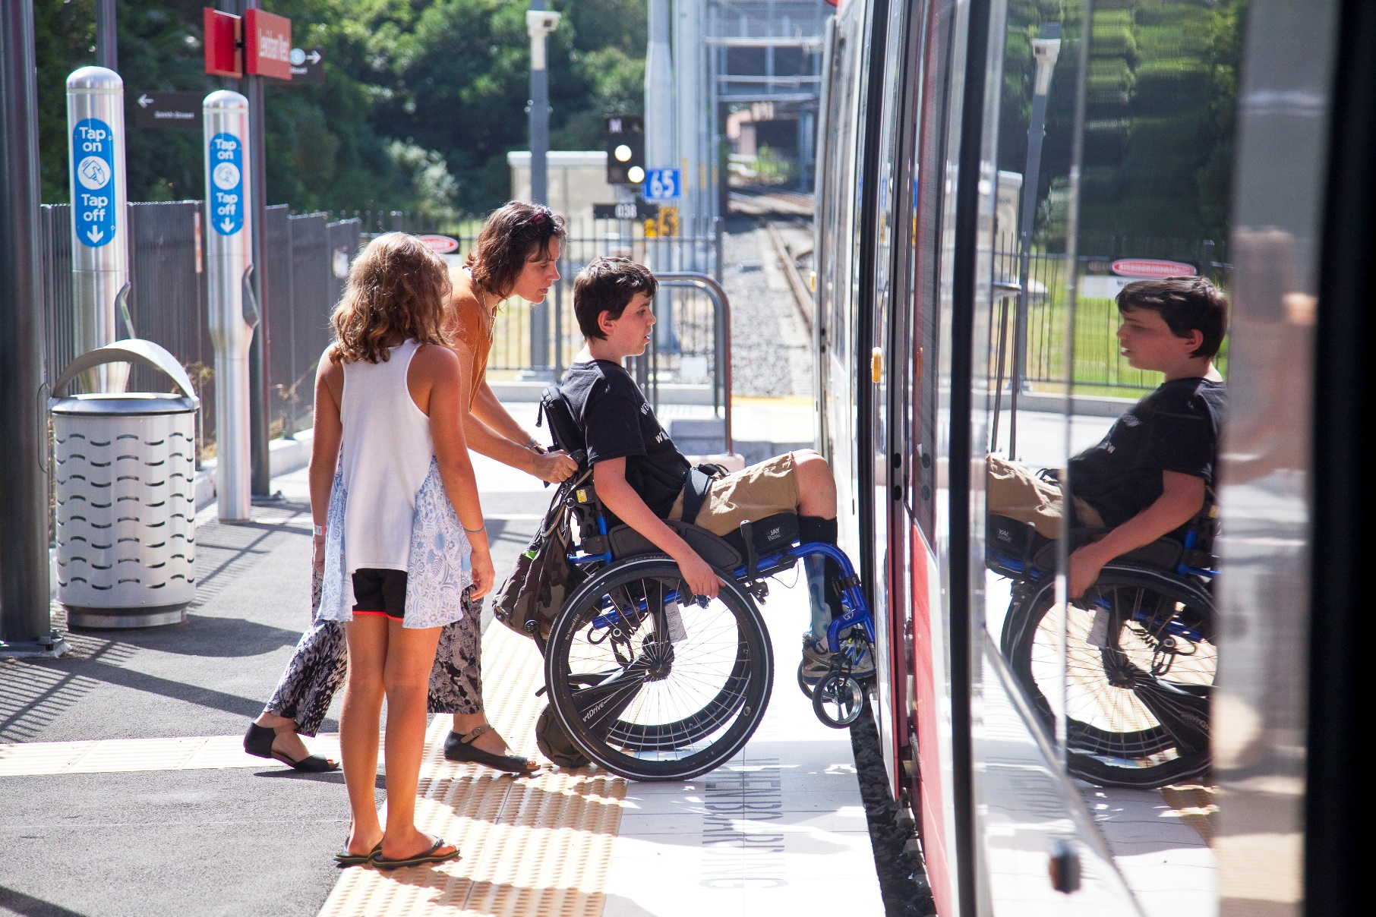


Transdev Australasia
Accessibility and Inclusion Action Plan
2020-2023

Table of Contents
Message from our CEO 3
About Us 4
Our Services 5
Our Vision 6
Our Priorities 7
Priority 1: Accessible and Inclusive Workplace 8
Priority 2: Accessible and Inclusive Recruitment 9
Priority 3: Career Development, Education and Training 10
Priority 4: Information and Technology 11
Priority 5: Customer Service 12
Priority 6: Accessible Public Transport 13
Monitoring and Evaluation 14

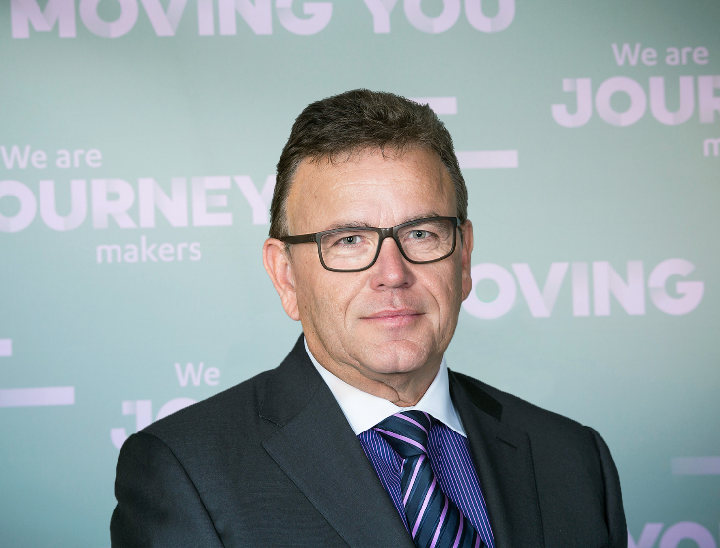

Message from our CEO

I am proud to present Transdev’s Accessibility and Inclusion Plan for 2020-2023.

Transport is an essential service for everyone in our community. It is especially important for people with disabilities to help them achieve social and economic participation.

With more than 1 in 5 Australians living with a disability, an increasingly ageing population and 20% of Australians speaking a language other than English at home, it is important that we design our products and vehicles and deliver our services with accessibility in mind.

This Plan is our commitment to make our services more inclusive and accessible for everyone in our community. It is also a Plan to ensure that our workplace and recruitment practices are more inclusive and accessible to everyone who wishes to work with us.

In addition, we will continue to ensure that we are meeting our obligations under the Disability Standards for Accessible Public Transport 2002.

We have set measurable goals in this Plan which we will monitor and report on regularly.

I look forward to working with everyone at Transdev to deliver this Plan and ensure we meet our goals.

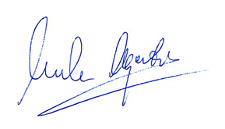

Luke Agati
CEO Transdev Australasia

Our Business
Melbourne
Sydney
Brisbane
Perth
Auckland
Wellington

Transdev is at the heart of keeping our communities moving. We provide public transport services in seven locations in Australia and New Zealand. We pride ourselves on leading the way in public transport through the collaboration of our teams and a shared commitment to excellence in all that we do.

We are located in 17 countries, on 5 continents, and operate 17 different modes of transport.

We deliver 11 million passenger trips everyday thanks to efficient, easy to use and environmentally friendly transportation services that connect people and communities.

We specialise in the operation and maintenance of a number of transport modes including passenger trains, light rail, ferries, buses and coaches.

Bus
Rail
Ferry
Light Rail
Coach
On demand ferry & shuttle

Our approach is rooted in long term partnerships with business and public authorities, and in the relentless pursuit of the safest and most innovative mobility solutions.

At Transdev, we have a purpose which motivates us profoundly. It is both very simple and very deep because moving is essential to connect with people, to work, to study, to take care of one’s health…and to simply live.

We empower your freedom to move every day.

Because mobility is infinitely human, we define ourselves as people serving people.

That is why we commit collectively to always serve our customers, communities and businesses better.

Our Services

At Transdev, we believe public transport plays an important part in how a city comes to life. Our day to day work influences where our families, friends and future generations will live, work and play.

6090 employees
in Australasia

Since 1998, Transdev has operated public transport networks all over Australia, enabling millions of customer journeys every year.

Our team of 6,090 people are Journey Makers – people who make trips memorable. They share their spirit, personality and enthusiasm with everyone they encounter.
7 transport modes
4 Australian locations

Melbourne: We operate and maintain 30% of Melbourne’s bus routes including the highly utilised SmartBus services.

Brisbane: We operate numerous bus routes including important school services.

Sydney: Our team operate numerous bus routes, on demand services, the iconic Sydney Ferries services and the light rail network. In December 2019, we commenced operating the newest Sydney light rail network which will significantly change the way Sydneysiders use their city.

Perth: We are one of the leading bus operators with services in the Rockingham, Mandurah, Fremantle and Perth areas including the free Central Area Transit (CAT) buses.

137 million
journeys per year

As we play a central role in connecting so many local communities, it’s important that our services are accessible to our diverse passengers with different accessibility requirements and needs.

Our Vision

As one of the leading providers and operators of public transport, our vision is that all our services, information, vehicles, and infrastructure are accessible to all people - specifically those with diverse disabilities and access needs.
Our vision is also to ensure that our workplace is accessible and inclusive of all our staff. This includes ensuring that employees with disabilities feel supported and included at work.
Accessibility affects many people using public transport including:
- People with disabilities and their carers
- Older people
- People from diverse cultural and linguistic backgrounds
- Passengers with luggage
- Parents with prams

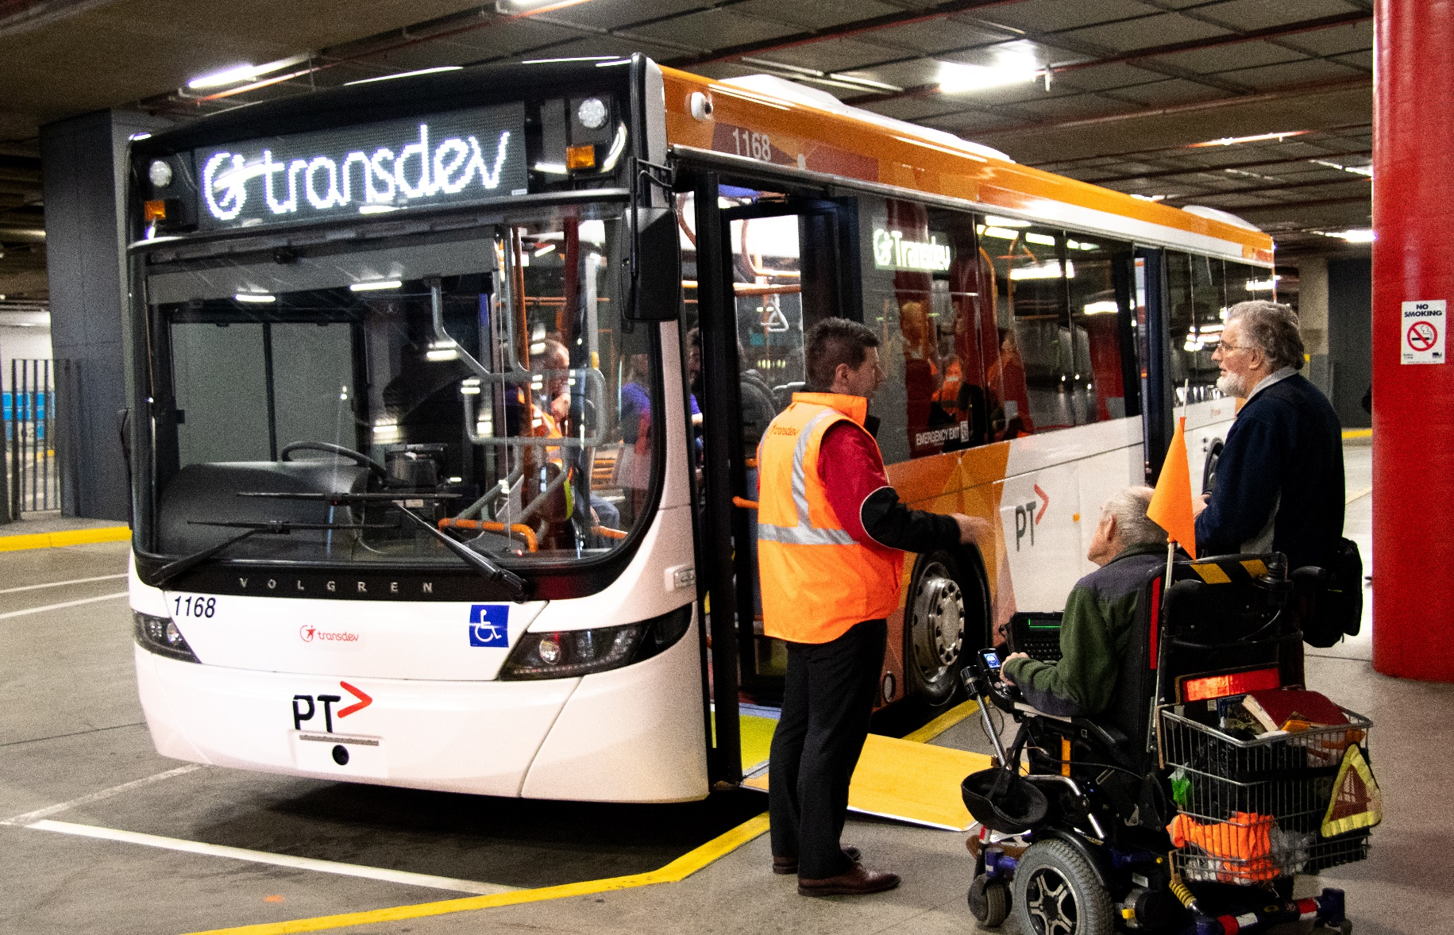

Our Priorities

Priority 1: Accessible and Inclusive Workplace
Priority 3: Career Development, Education and Training
Priority 4: Information and Technology
Priority 5: Customer Service

Priority 6: Accessible Public Transport

Priority 2: Accessible and Inclusive Recruitment

Accessibility and Inclusion Action Plan
Key Priorities

Priority 1: Accessible and Inclusive Workplace
Objective: To be an accessible, flexible and inclusive workplace for all our employees
Action | Responsibility | Timeframe
We will conduct a review of all Transdev workplace policies to ensure there are no unintended discriminatory provisions that may lead to discriminatory practices against staff with disabilities. | General Manager, Talent, Diversity, Learning and Engagement | January 2021
We will conduct a review of all Transdev workplace policies to ensure that they are accessible. | General Manager, Talent, Diversity Learning and Engagement | January 2021
We will collect baseline data to identify the experiences of, and challenges that staff with disabilities face. | Diversity and Engagement Advisor | April 2021
We will commemorate events that raise awareness and celebrate the achievements of people with disabilities, including International Day for People with Disability | Diversity and Engagement Advisor | Ongoing
We will develop and promote a workplace flexibility policy that responds to, and supports the needs of, staff with disabilities and staff who are carers of people with disabilities. | General Manager, Talent, Diversity, Learning and Engagement | Ongoing  July 2021
We will establish an Accessibility Employee Network to consult on, and promote, accessibility initiatives at Transdev. | Diversity and Engagement Advisor | July 2021
We will review our procurement policies for opportunities to implement and promote accessibility and inclusion strategies and initiatives. | General Manager Procurement | January 2021
We will provide appropriate ongoing support for new staff who have disclosed a disability, and their managers. | People and Culture Manager (for each Business unit) | Ongoing
We will conduct a review of accessibility of all current premises and consider opportunities for improvements to ensure that all Transdev premises are fully accessible for all people including those with a disability. | Director of Asset Management | Ongoing December 2022
We will formally appoint a Senior Executive as an Accessibility and Inclusion Champion to promote awareness and role-model inclusive behaviour. | Director of Asset Management | December 2020
We will develop a Mental Health and Wellbeing Plan to support staff with their mental health wellbeing. | Health, Safety, Environment and Quality Officer | Ongoing  December 2020
We will promote this Accessibility and Inclusion Action Plan to all our employees and partners and ensure it is accessible and readily available. | Senior Communications Advisor | December 2021  Ongoing

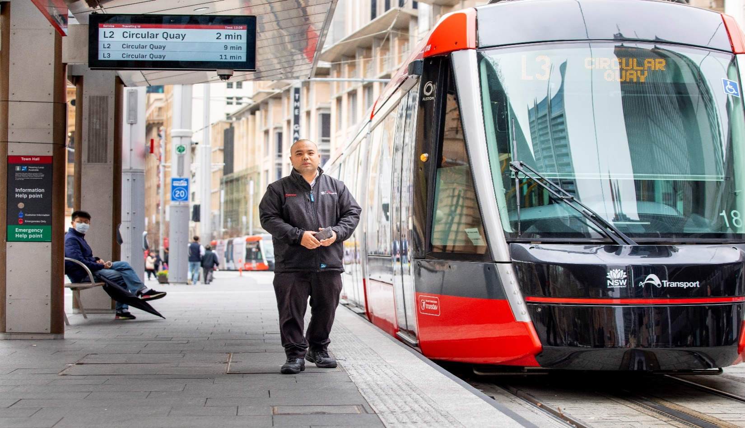
Priority 2: Accessible and Inclusive Workplace
Objective: To remove barriers in recruitment for people with diverse disabilities and access requirements
Action | Responsibility | Timeframe
We will review and amend Transdev job descriptions to ensure only inherent requirements of the job are included and that people with disabilities are encouraged to apply for roles | Talent Acquisition Manager | February 2021  Ongoing
We will review recruitment processes and practices to identify and remove any unintended barriers for candidates with disabilities | Talent Acquisition Manager | February 2021
We will deliver disability awareness training to recruitment staff including accessibility and inclusion principles, workplace adjustments and diversity strategies annually and to new staff | Talent Acquisition Manager and People and Culture Manager | Annually  January 2021
We will establish and develop partnerships with disability employment organisations to assist in sourcing, attracting and recruiting staff through platforms such as the National Disability Employment Services and the Disability Employment Service | Talent Acquisition Manager | July 2021
We will look for opportunities to advertise employment opportunities in media specifically targeted to people with disability such as JobAccess | Talent Acquisition Manager | July 2021  Ongoing
We will conduct a review of Transdev’s online career portal for accessibility | Transdev IT Team and Talent Acquisition Manager | October 2021  Ongoing
Priority 3: Career Development, Education and Training
Objectives: To foster a culture of disability and accessibility awareness and confidence in the workplace
Action | Responsibility | Timeframe
We will conduct a survey that will determine existing staff disability awareness, attitudes and perceptions toward people with disabilities and utilise results for future training programs and initiatives | Diversity and Engagement Advisor | April 2021  Ongoing
We will review the training currently provided with regard to disability awareness and accessibility and determine whether additional or new training is required. | General Manager, Talent, Diversity Learning and Engagement | Ongoing
We will review opportunities to include people with disabilities as paid Transdev trainers | General Manager, Talent, Diversity Learning and Engagement | July 2021
We will include training on accessibility in our induction training for all new staff | General Manager, Talent, Diversity Learning and Engagement | December 2020
We will ensure that employees with disability have the same access to career development and leadership training and opportunities as other workers at the same level | People and Culture Manager (for each Business unit) | July 2022  Ongoing
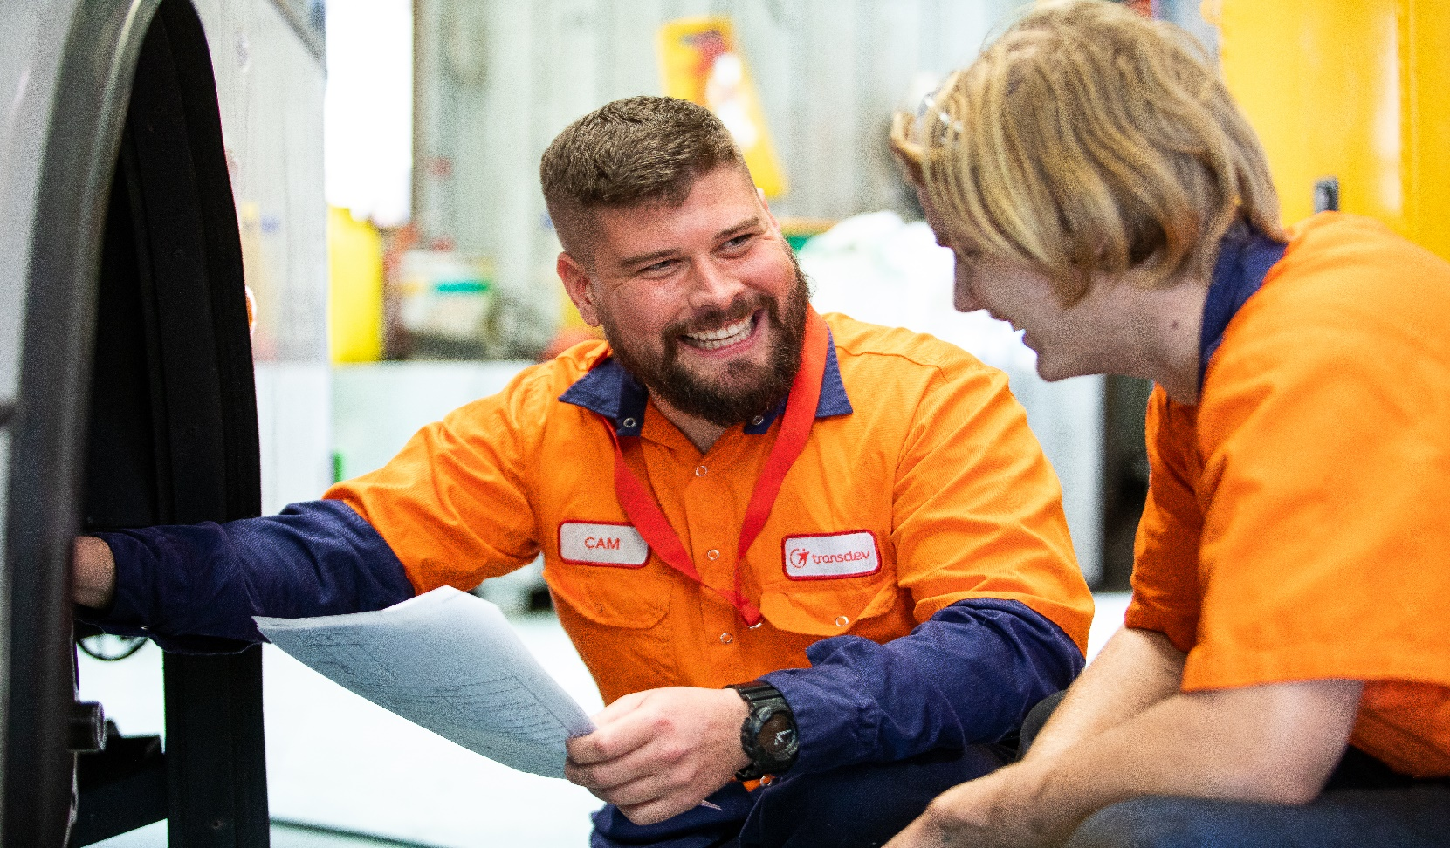

Priority 4: Information and Technology
Objective: Technology is used to improve the provision of information in an accessible and inclusive manner
Action | Responsibility | Timeframe
We will review our website and mobile app to ensure it is compliant with Accessibility Guidelines. | Senior Communications Advisor | November 2021  Ongoing
We will develop an Accessible and Inclusive Communications Policy and Guideline for all internal and external communications material and roll this out across Transdev | Senior Communications Advisor | February 2021  Ongoing
We will ensure that customer input, testing and feedback is included as a key component in any new website or mobile app design and update | Senior Communications Advisor | Ongoing
Where possible, we will ensure that our internal and external communication material is representative of people with diverse range of disabilities | Senior Communications Advisor | September 2021
We will include information regarding accessibility on our websites | Senior Communications Advisor | July 2021  Ongoing

Priority 5: Customer Service
Objective: Information on transport services and customer services support are accessible
Action | Responsibility | Timeframe
We will review all external communication material and publications on public transport for accessibility | Communications Manager in each Business Unit and relevant Public Transport Authority | July 2021
We will develop a procedure or mechanism for handling customer complaints regarding disability discrimination and make it more accessible | Customer Experience Manager and General Manager, Talent, Diversity Learning and Engagement and relevant Public Transport Authority | July 2021
We will include accessibility among customer satisfaction indicators in any feedback or survey form | Customer Experience Manager in each Business Unit | July 2021
We will develop and deliver training on accessibility to all new customer service staff within 6 months of commencement and refresher training to existing staff, as required by each business unit, to support their understanding of disability and how to support customers with access requirements | Customer Experience Manager | Annually  Ongoing

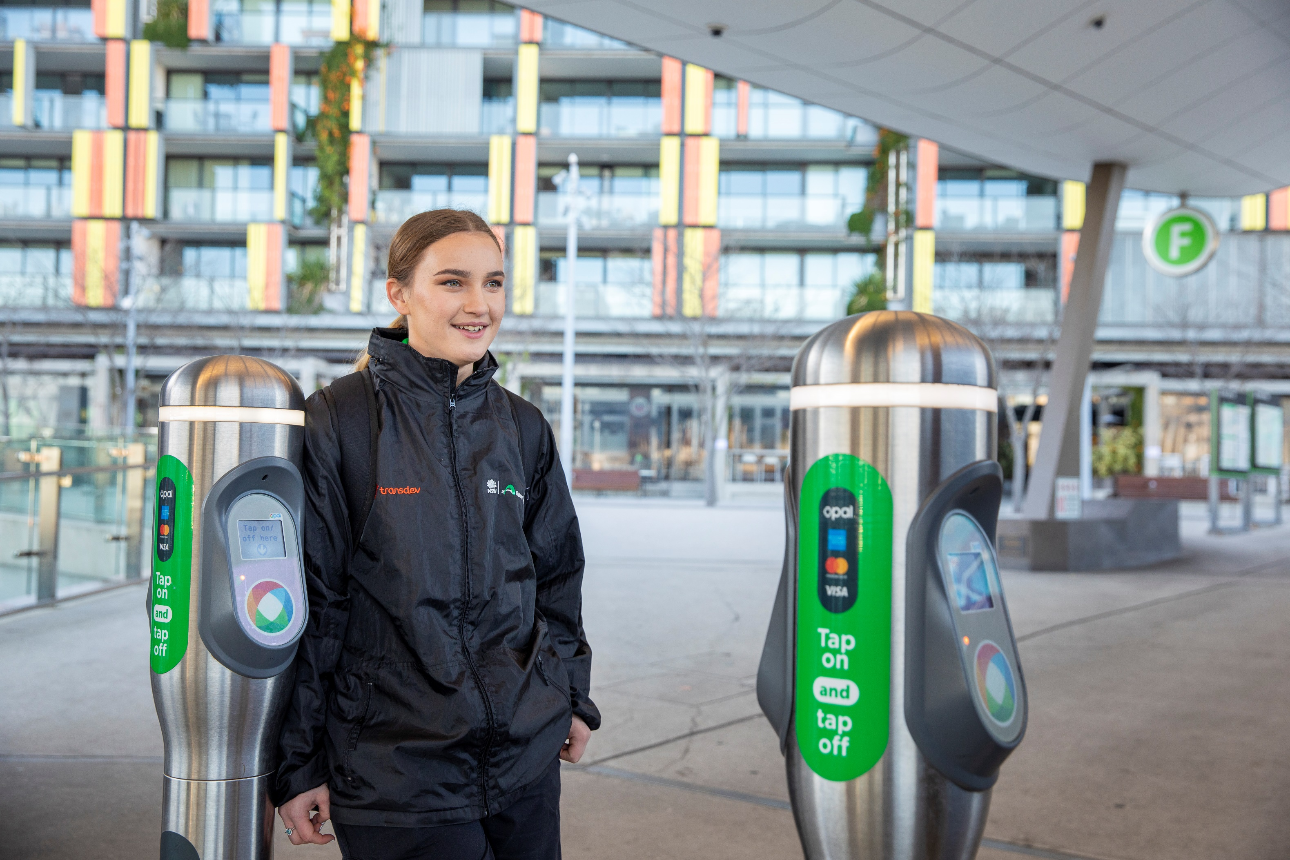

Priority 6: Accessible Public Transport
Objective: To remove barriers to accessing public transport and to ensure that all products and services are co-designed with people with diverse disabilities and access requirements
Action | Responsibility | Timeframe
We will set up an Internal Working Group to monitor Transdev’s compliance with the Disability Standards for Accessible Public Transport 2002 | General Manager, Talent, Diversity Learning and Engagement | July 2021
We will continue to work towards becoming compliant with the Disability Standards for Accessible Public Transport 2002 | Director of Asset Management, chief Legal and commercial Officer  and relevant PTA | December 2022  Ongoing
We will establish an Accessibility Reference Group that includes diverse organisations or people representing members of the community with a disability; members of the community that are ageing; people with other access needs and their carers to provide expert guidance on accessibility and inclusion initiatives | General Manager, Talent, Diversity Learning and Engagement | July 2021
We will continue to represent Transdev at appropriate working groups, disability forums, community groups or information sessions relating to Accessible Transport. | Diversity and Engagement Advisor | Ongoing
We will ensure that all public consultations to inform future transport outcomes are accessible by people with disability and other accessibility needs | Senior Communications Advisor and Customer Experience Manager in each Business unit | Ongoing
We will ensure that people with disabilities and other accessibility needs are involved in design, product testing for new public transport fleet and infrastructure | Customer Experience Manager in each Business unit | Ongoing
We will ensure that we have mechanisms in place to enable us to consult people with disability or accessibility needs in rural and remote areas. | Customer Experience Manager and General Manager, Talent, Diversity Learning and Engagement | Ongoing

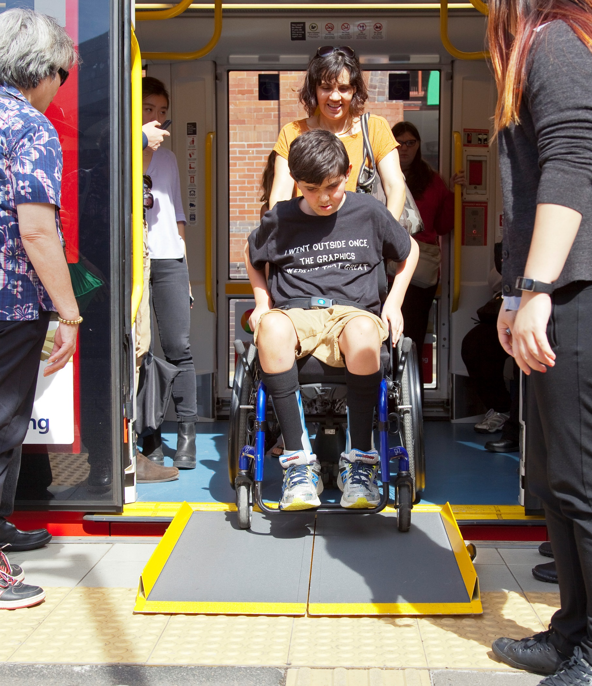

Monitoring and Evaluation

Transdev will monitor the implementation of each of the action items in this Accessibility and Inclusion Plan, in consultation with the relevant Manager and Business Unit.

Reports on the overall implementation of Transdev’s Accessibility and Inclusion Plan will be provided to the General Manager - Talent, Diversity, Learning and Engagement on a quarterly basis.

Each responsible Manager and Business Unit will be responsible for recording their progress in implementing each action item and providing their reports to the General Manager - Talent, Diversity, Learning and Engagement quarterly.

The success of implementing action items under this Plan will be measured through various methods, including:
- Customer feedback analysis
- Customer satisfaction levels across the different modes
- Staff surveys
- Qualitative feedback provided from analysis of exit interviews
- Employment and retention rates for staff with disabilities

The General Manager – Group Talent, Diversity, Learning and Engagement will monitor and track progress against each action item.

Progress on implementation of the Plan will also be reviewed annually.

The final implementation report will be included in Transdev’s next Accessibility and Inclusion Plan.

Contact details
Georgia James
Diversity and Engagement Advisor
0439 113 953
georgia.james@transdev.com.au



